**Project Proposal**

**Fall Detection and Monitoring for Oldsters**

**Initial Plan:**

**Description**

* This system will help to detect falls among the old whenever they face this problem. report the same to their family members, emergency care centers. Therefore, the old ones can get adequate care timely.
* The system does it with the help of ADXL345 present in the system which compares the values passed by the motion.
* ESP32 cam along with raspberry pi will take images as well for the accuracy of the location.
* Whenever a fall is detected, the system will capture the images and send them to the cloud by alerting the family and guardians.

**Features:**

ADXL345 senses the fall.

It is a real time system which stores data in the cloud and can be accessed easily.

The data is sent to the cloud and can be accessed from anywhere using a Mobile device.

Panic button with Buzzer.

**Hardware Requirements:**

* Power Unit
* Regulator
* ADXL345
* Raspberry Pi 4
* GSM Module
* GPS Module
* Camera (ESP32),Resistors
* Battery & Panic button
* Buzzer, Sensors(Pulse rate sensor and Temperature sensor)

**Software Components**

1. EASYEDA is an online platform to design schematic and PCB
2. Arduino software
3. mobile BLYNK App is used to store on BLYNK cloud and to process the images
4. Raspbian is a free operating system for Raspberry Pi 4.
5. Geany is a text editor

**Hardware:** The hardware components used to complete this project are Power supply unit (rechargeable batteries), regulator, Accelerometer, Pulse rate sensor, Panic buzzer, ESP32, Raspberry pi 4, Temperature sensor, Panic Button, GPS/GSM modules and Antennas. We will also use some resistors in our project.

There are many other components used to connect, assemble and make the project working. Soldering iron is one of them. It will be used to assemble the components with each other. Multimeter and cutter, a laptop for coding etc.

**REGULATOR**

The regulator has a much cleaner output voltage than a buck converter in most cases. So, if your circuit is sensitive to changes in the input voltage a regulator may be better.

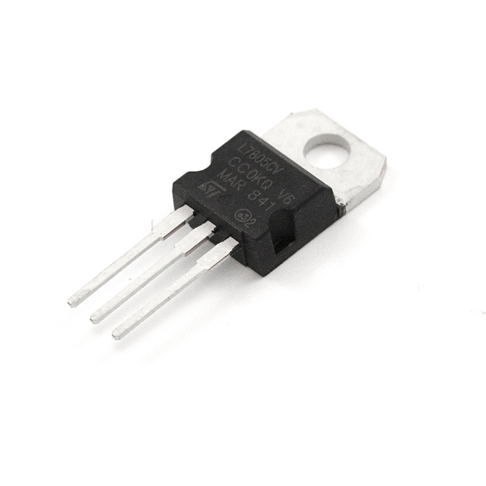

**GSM AND GPS**

Most GPS and GSM modules use a UART interface. But since Raspberry Pi has only one UART port, you can connect only one module (GPS/GSM) via UART and for the other module you have two options:

1. Choose a module (GPS/GSM) that supports other interfacing protocols like USB or I2C or SPI.
2. Alternatively, you can use a USB to UART converter with one of the modules and connect it to one of the USB ports of R Pi.

It is not a good choice to use a combo version of GSM and GPS as it leads to delays. When delays are there, the message of fall cannot be delivered quickly. It will lessen the efficiency of the system. Ultimately, the system becomes unreliable**.**

Secondly, if the combination of GSM and GPS is implemented, either the position or the message can be transferred. Both can't function together. So, the best option is to use them separately, as the purpose is to get the message as quickly as possible.

**PULSE RATE SENSOR**

The heart rate sensor measures your heart rate in Beats per Minute using an optical LED light source and an LED light sensor. The light shines through your skin, and the sensor measures the amount of light that reflects back. The light reflections will vary as blood pulses under your skin past the light.

**Panic Button:** For any emergency help, in case of an indoor situation where family members get to know that the oldster needs help or is outdoors so the people can hear there is a person who needs help.

**Raspberry pi 4:**

1. Operating temperature ranging from 0 to 50 degrees C ambient.

2. It includes onboard storage in the form of 4GB eMMC Flash.

3. Price: The Raspberry Pi 4 is reasonably priced and starts at $35 for a 1GB variant, but the 4GB variant can cost you about $55.

4. Connectivity: The Raspberry Pi 4 is pretty well spaced out. For input/output connectivity, it features a 40 pin GPIO header, 2- lane MIPI DSI and 2-lane MIPI CSI connectors, 4-pole stereo A/V port, and four USB.

5. To handle video output, the Raspberry Pi 4 comes with dual micro-HDMI ports that deliver 4K video output. 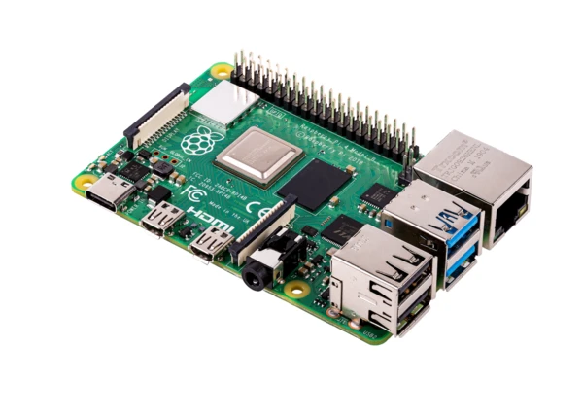

**Software Components:** We will use Eclipse IDE as a platform for programming, an editor would be used to write the code for our project in C/C++. After compiling and debugging the program would be ready to transfer on the microcontroller.

According to our research EASYEDA will be good for simulation to avoid possible errors in the system and will then convert it into a hardware system.

For live images, we will use the BLYNK Cloud and BLYNK app.

Raspberry Pi 4

MCU

Power Management

Temperature Sensor

Pulse Rate Sensor

ADXL345 Sensor

Panic Button

Buzzer

ESP32

Data on Cloud

GPS Module with Antenna

GSM Module with Antenna

I2C

5v

UART

**Block Diagram for Fall Detection and Monitoring Device for Oldsters**

Denotations

Red line= Power

Blue Line= Data

Green Line = Power & Data

**Engineering diagram:**

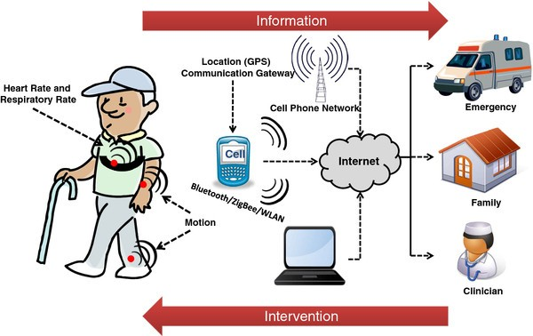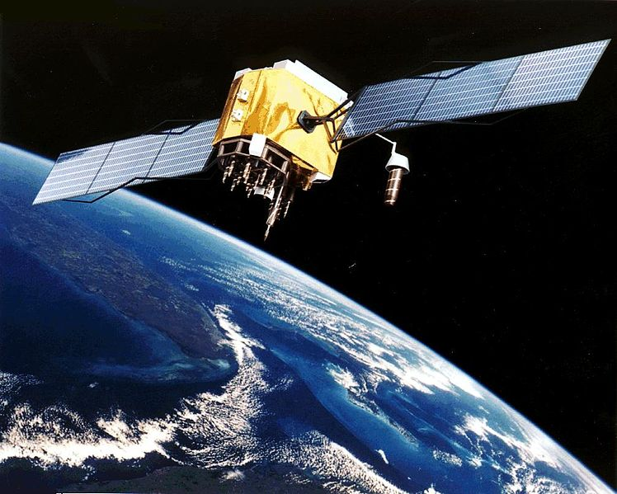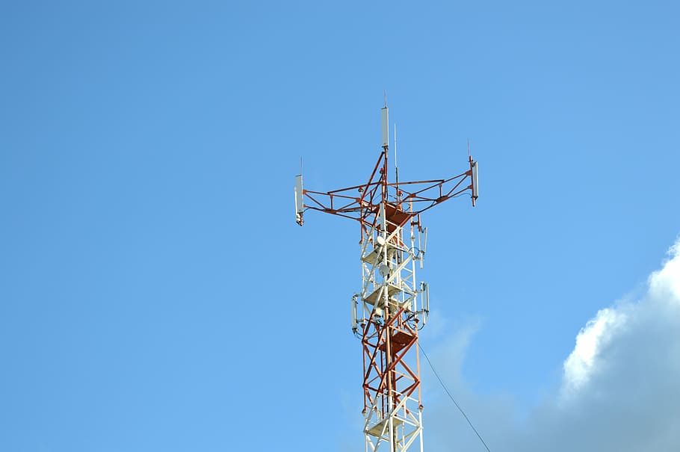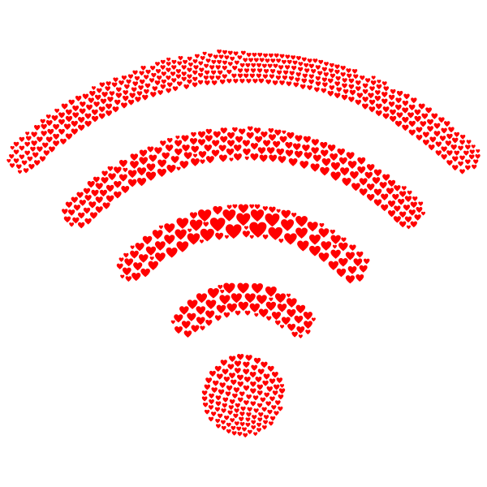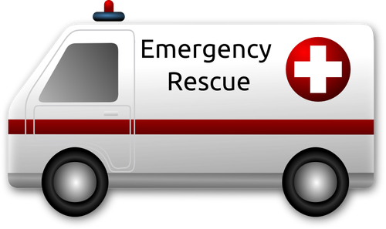

**motion**

**Signal sent to GPS & GSM**

Pulse rate sensor, temperature sensor

**Emergency**

**clinic/ care centre**

**Family**

**GPS**

**GSM**

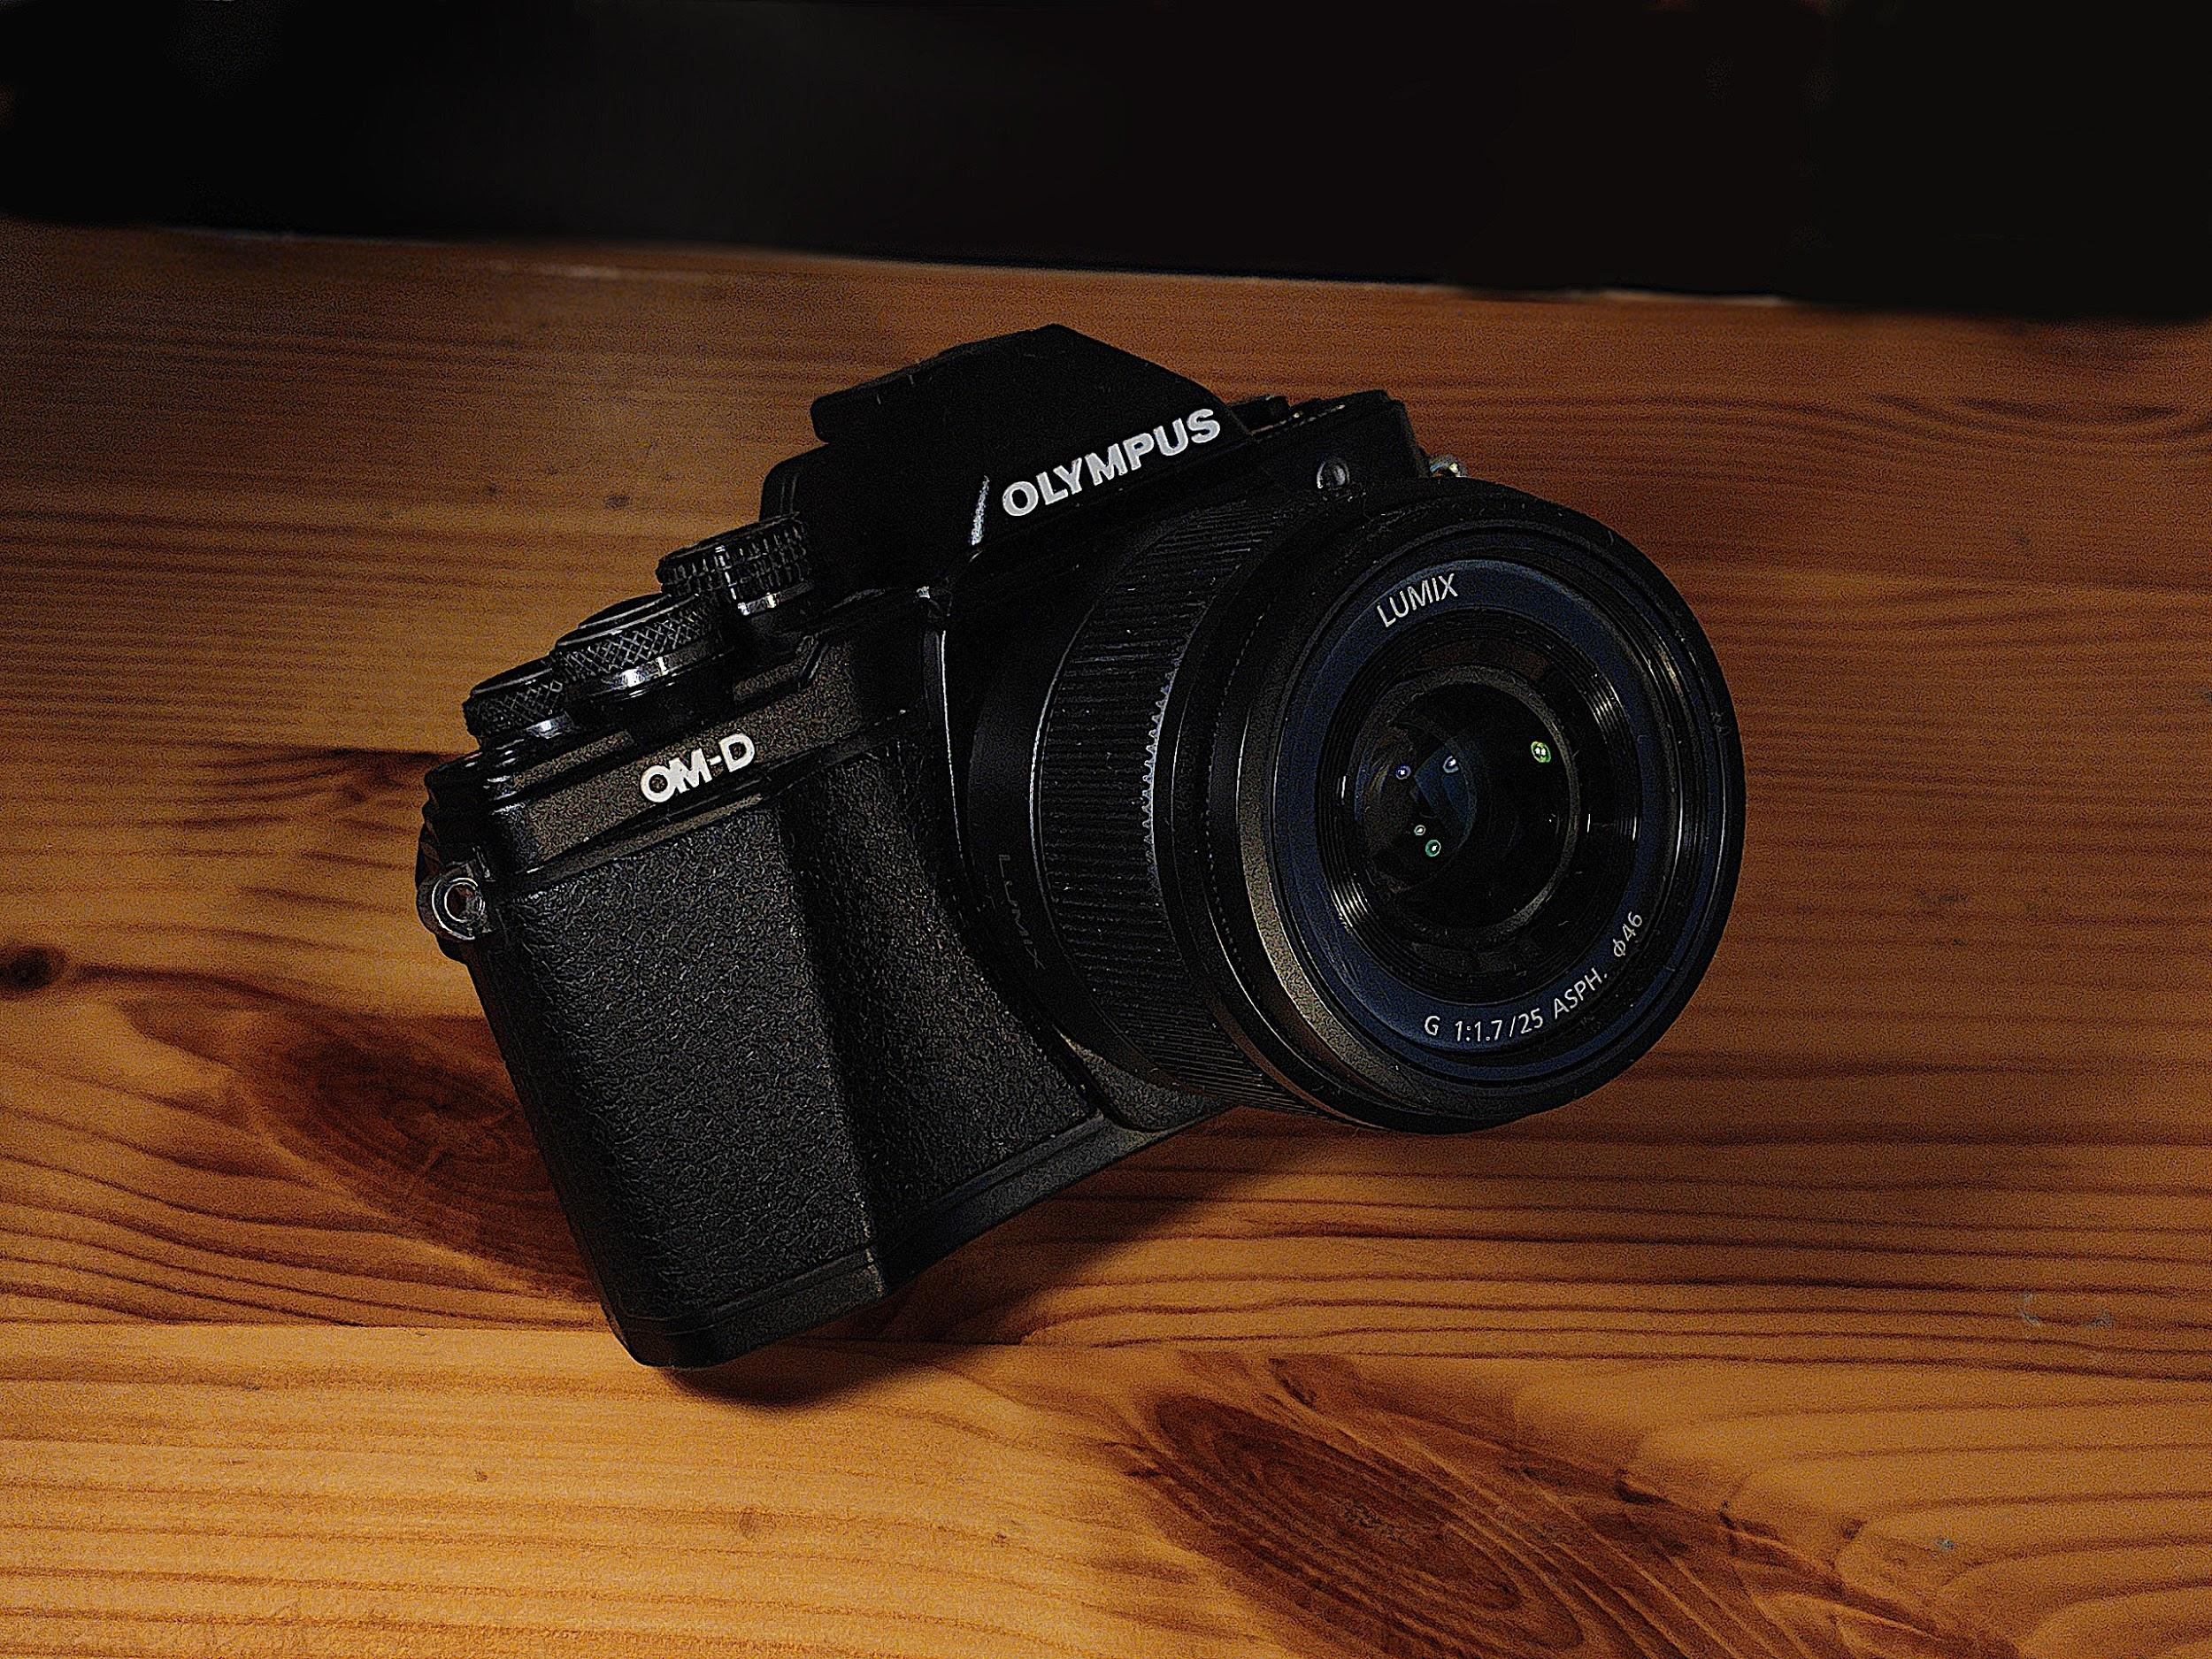

**Camera**

Panic button

**How our system is real time:**

As we know, our Raspberry Pi 4 has a Broadcom processor.

Which can be seen from the datasheet of the RPi 4 <https://static.raspberrypi.org/files/product-briefs/200521+Raspberry+Pi+4+Product+Brief.pdf>

If using this kind of processor then it is obvious that the processor is capable of handling multiple processes if we want.

So, our system will work in real time by using threads in our project.

Actually, threads help us to run a project in an asynchronous mode.

The system will dynamically get input and produce output based on conditions.

**Flow chart :**

We use a flow chart to offer a clear picture of the process and to find ways to improve project efficiency. A flow chart displays graphically the project’s objective and seeks to more logically order the activities therein. But, a flow chart can also help with monitoring progress and even status reporting.

The flow chart is one of the many tools you need to control the project. With the right project management software, your management can be even more productive and efficient. But before we get to that, let’s look a little more closely at the flowchart for this project.

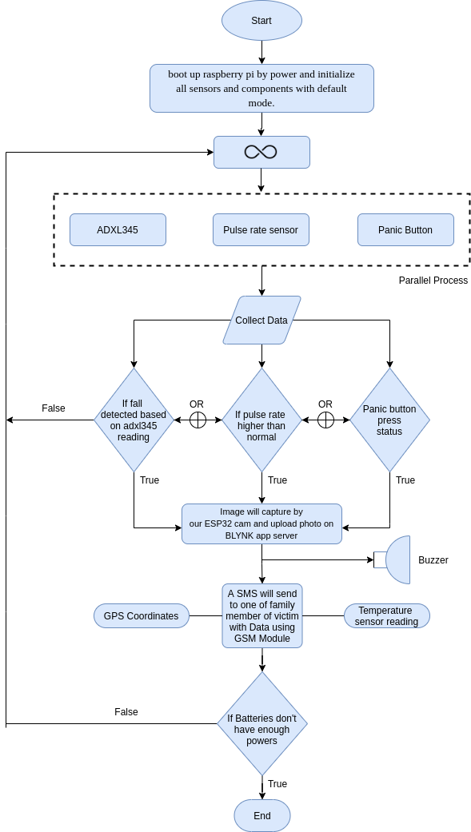

Sms generated in the last phases will have the information about geolocation coordinates, pulse rate and temperature .

**Simulation tool:**

Simulator Software ---> Proteus 8.x (x denotes version number)

**Do**:

We can use the Proteus 8.x version as a simulator software in which we will add Raspberry Pi 3 Library, ADXL345, GPS, Pulse rate sensors and some other basic components available for simulation.

**Don’t:**

We can’t use the C/C++ programming language for our Raspberry Pi simulation because Proteus supports the Raspberry Pi board with a Python interpreter. So no compiler available for Raspberry Pi, the whole simulation will be based on python language.

**How to use any standard for design, communication or coding**

* **Design Standards for Fall Detector Project:**

**Performance:** Our Embedded system is deployed to have high performance with minimum power dissipation.

**Power:** System should consume less power.

**Size:**The small size systems with on board RAM and ROM memory.

**Safety:**As most Embedded systems are IOT based, safety is prime important.

* **Communication Standards For Fall Detector Project:**

**I2C: i**t is a hardware protocol which is used to communicate with a peripheral with MCU. We will use this protocol to interface ADXL345 with Raspberry pi4.

**UART communication protocol: i**t is also a hardware protocol which is used to communicate a peripheral with MCU. We will use this protocol to interface GSM, GPS module with Raspberry Pi4.

* **Coding Standards of C++: International Standard ISO/IEC 14882:2020(E)**

It is a widely used international standard for software development under which there are some set of rules or guidelines for c/c++ programming development to develop any kind of Kernel of any operating system. We can also make any embedded application.

**Ethical, Legal & Environmental Ramifications**

**Ethical Ramifications:**

* Consent to share personal data with family members or caregiver:

We are sharing someone's location with another person but before doing that we need to make sure that the person tracking the moments has the consent of an oldster. As, there might be a situation where an oldster doesn't want to share their position with anyone. In those situations, someone who is forcefully tracking an old person is unethical.

* Consent to share photo with family members or caregiver: As in case of emergency or fall detection photo will be shared so, it is possible that the user might be in its personal space which makes it important for users to understand what they are agreeing to.

**Legal Ramifications:**

* MAiD (Medical Assistance in Dying): Some people have filled a form requesting help in dying rather than being saved in Hospitals so, those people rather than being saved are legally required to go the way they desire. Saving people with these forms can cause legal problems.
* Code Of Conduct:
* acceptable use policy: Anybody using the data received either on cloud or mobile device should make sure personal data is not shared outside the personal space.
* internet access policy: It is possible their carrier may charge them for internet use or for the short message sent so, users used to confirm with their carriers.

**Environmental Ramifications:**

We need to think about a sustainable way where we can recycle or reuse the material used to reduce the harmful effect associated with the material used on the environment so that we can reduce the carbon footprint which causes Global Warming.

**BOM(Bill Of materials)**

|  |  |  |  |  |  |
| --- | --- | --- | --- | --- | --- |
| **Cost Estimation of Fall Detector Project** | | | | | |
| **Component Name** | **Part no.** | **Qy** | **Cost** | **Est. Cost** | **Reference Link** |
| Raspberry pi 4 | 1690-RaspberryPi4B/4GB-ND | 1 | 97.65 | 97.65 | [RASPBERRY PI 4 MODEL B 8G](https://www.digikey.ca/en/products/detail/raspberry-pi/RASPBERRY-PI-4-MODEL-B-8G/12159401) |
| ADXL345 | ADXL345BCCZ-EP-ND | 1 | 22.79 | 22.79 | [Adafruit Industries LLC | Development Boards, Kits, Programmers | DigiKey](https://www.digikey.ca/en/products/detail/adafruit-industries-llc/1231/4990764?utm_adgroup=General&utm_source=google&utm_medium=cpc&utm_campaign=Smart%20Shopping_Product_Zombie%20SKUS&utm_term=&productid=4990764&gclid=Cj0KCQjwsqmEBhDiARIsANV8H3YJNIYE4ya-yPsSd3DbumcUcUlIAW5OkW6tmwSCbVa61uJUr2C9PfcaAoC-EALw_wcB) |
| Battery(18650) | 18650 Vtc6 30A 3.7 V 3000Mah | 4 | 44.02 | 44.02 | [Battery Li-ion](https://www.amazon.ca/3000Mah-Bater%C3%8DA-Recargable-Juguetes-Linterna/dp/B0933LC9X7/ref=sr_1_35?crid=2LRVX675DTF7S&dchild=1&keywords=3000mah+3.7v+18650&qid=1622735966&sprefix=3000mah+%2Caps%2C176&sr=8-35) |
| Neo 6-M GPS module | PA6H1F1702 | 1 | 39.95 | 39.95 | [Adafruit Ultimate GPS Breakout - 66 channel w/10 Hz updates [Version 3] : ID 746 : $39.95 : Adafruit Industries, Unique & fun DIY electronics and kits](https://www.adafruit.com/product/746) |
| GSM Module(SIM7600) | SIM7600A-H, 4G | 1 | 72.89 | 72.89 | [GPS Module](https://www.amazon.com/4G-HAT-SIM7600A-H-Communication-Positioning/dp/B07PLTP3M6/ref=mp_s_a_1_2?dchild=1&keywords=sim7600+gsm+module&qid=1622737314&sr=8-2) |
| Temperature Sensor(DS18B20) | 1738-1257-ND | 1 | 11.09 | 11.09 | [Temperature Sensor](https://www.digikey.ca/en/products/detail/dfrobot/KIT0021/7087154?utm_adgroup=Evaluation%20Boards%20-%20Expansion%20Boards%2C%20Daughter%20Cards&utm_source=google&utm_medium=cpc&utm_campaign=Shopping_Product_Development%20Boards%2C%20Kits%2C%20Programmers_NEW&utm_term=&productid=7087154&gclid=Cj0KCQjw--GFBhDeARIsACH_kdZWcQ7ywyWuBJYN-YjOvJOY-jG0cJ_12fEbys08OtHS8r09im3TjJoaAgd6EALw_wcB) |
| Pulse Rate Sensor | 1568-1247-ND | 1 | 34.59 | 34.59 | [Pulse rate sensor](https://www.digikey.ca/en/products/detail/sparkfun-electronics/SEN-11574/5762397?utm_adgroup=Gadgets%2C%20Gizmos&utm_source=google&utm_medium=cpc&utm_campaign=Shopping_Product_Maker%2FDIY%2C%20Educational_NEW&utm_term=&productid=5762397&gclid=Cj0KCQjw--GFBhDeARIsACH_kdbYyiFN96JQTRzC3bv6OkJeg3r5zLATnCUkZ5gtXxgx_6csZVVVkNsaAo5jEALw_wcB) |
| Soldering Equipments |  | 1 | 36.98 | 36.98 | [Soldering Kit with Basic Equipments](https://www.amazon.ca/Multimeter-Rarlight-Temperature-Desoldering-Screwdriver/dp/B07L3VNMKX/ref=sr_1_8?crid=1NILSU1EMK9V0&dchild=1&keywords=soldering%2Biron%2Bkit&qid=1622734193&sprefix=soldering%2B%2Caps%2C196&sr=8-8&th=1) |
| PCB design |  | 1 | 60 | 60 | Approximate |
| 78S05 Voltage Regulator | YA14-US-Y006977 | 2 | 2.20 | 2.00 | [Regulator](https://www.amazon.ca/dp/B08H9NGM4K/ref=cm_sw_r_wa_awdb_imm_W2R8KR8AMA3YWXKFGB66) |
| ESP32 CAM MODULE |  | 1 | 16.99 | 16.99 | [ESP32](https://www.amazon.ca/Bestol-Tech-ESP32-CAM-Development-Bluetooth/dp/B07S1GVSPR/ref=sr_1_7?dchild=1&keywords=esp32+cam+module&qid=1622737321&sr=8-7) |
| Battery Holder |  | 2 | 7.59 | 7.59 | [Battery Holder](https://www.amazon.ca/Thicken-Battery-Holder-Switch-QTEATAK/dp/B08L79C8JZ/ref=sr_1_10?dchild=1&keywords=battery+holder+18650&qid=1622737464&sr=8-10) |
| Belt |  | 1 | 16.99 | 16.99 | [Belt](https://www.amazon.ca/dp/B07BFSMCCZ/ref=cm_sw_r_wa_awdb_imm_C4ENJSP9XKSEBSXPE3M8?_encoding=UTF8&psc=) |
| Push button and Buzzer |  | 1 | 9.79 | 9.79 | [Push Button](https://www.amazon.ca/C-J-SHOP-Miniature-Momentary-Tactile/dp/B01CGMP9GY/ref=sr_1_8?crid=6EZCWTEKKE55&dchild=1&keywords=tactile+switch&qid=1622738616&sprefix=tactile+%2Caps%2C181&sr=8-8) |
| LED |  | 4 | 2.0 | 2.0 | [LED](https://www.amazon.ca/eBoot-Pieces-Emitting-Diodes-Assorted/dp/B06XPV4CSH/ref=sr_1_5?dchild=1&keywords=led+100+piece&qid=1622739393&sr=8-5) |
| Raspberry pi adapter |  | 1 | 14.99 | 14.99 | [Raspberry pi Adapter](https://www.amazon.ca/LABISTS-Raspberry-Power-Supply-Listed/dp/B07W6T25Y4/ref=sr_1_9?dchild=1&keywords=raspberry+pi+4+adapter&qid=1622737887&sr=8-9) |

**References:**

1. Bell, K. (March 17, 2016). [Brain shrinkage’ increases traumatic brain injury risk in older adults who fall | Brain | UT Southwestern Medical Center (utswmed.org)](https://utswmed.org/medblog/tbi-older-adults/).
2. [Shmerling, R.](https://www.health.harvard.edu/blog/author/rshmerling)(March 14, 2016). [My fall last fall: Reaction time and getting older](https://www.health.harvard.edu/blog/my-fall-last-fall-201603149311)

<https://www.health.harvard.edu/blog/my-fall-last-fall-201603149311>

1. Seniors' Falls in Canada: Second Report. (n.d.) <https://www.canada.ca/en/public-health/services/health-promotion/aging-seniors/publications/publications-general-public/seniors-falls-canada-second-report/seniors-falls-canada-infographic.html>
2. Smith, M. (July 22, 2016). [Predicting Falls and When to Intervene in Older People: A Multilevel Logistic Regression Model and Cost Analysis (plos.org)](https://journals.plos.org/plosone/article?id=10.1371/journal.pone.0159365).
3. World Health Organization (January 16, 2018). A report about falls.
4. Segan, S. (April 29, 2021). Raspberry Pi 4 Overview.
5. Adafruit Description,(n.d). Retrieved from <https://www.adafruit.com/product/746>.
6. Emmet (Nov 17, 2019) Raspberry Pi Accelerometer using the ADXL345 <https://pimylifeup.com/raspberry-pi-accelerometer-adxl345/>

9) [Best Fall Detection Devices in 2021 | Fall Alert Systems (safehome.org)](https://www.safehome.org/medical-alert-systems/best/fall-detection/#:~:text=1.%20Bay%20Alarm%20Medical%20%E2%80%93%20Best%20Overall%20Fall,emergency%20center%20that%20is%20based%20in%20the%20USA.)

10) Software Radius., (n.d.) retrieved from

<https://www.softwareradius.com/easyeda-vs-eagle-pcb-designer/>

# 11) IoT Based Panic Button using ESP8266-01 (July 12,2019)retrieved from [IoT Based](https://iotdesignpro.com/projects/iot-based-panic-button-using-esp8266)

# [Panic Button Project using ESP8266-01 (iotdesignpro.com)](https://iotdesignpro.com/projects/iot-based-panic-button-using-esp8266)

12) Pulse Sensor(July 22,2018) retrieved from

[Pulse Sensor Pinout, Configuration & How Pulse Sensor Works (components101.com)](https://components101.com/sensors/pulse-sensor)

13) Brant, T.(August 7, 2019) Raspberry pi 4 retrieved from <https://www.pcmag.com/reviews/raspberry-pi-4>

14) Designing Step-Down (Buck) Switching Regulators., (n.d.)retrieved from [Designing Step-Down (Buck) Switching Regulators, how to Choose Inductor and Capacitor Values (mosaic-industries.com)](http://www.mosaic-industries.com/embedded-systems/microcontroller-projects/electronic-circuits/step-down-switching-regulator)

15) Software Radius., (n.d.) retrieved from

<https://www.softwareradius.com/orcad-vs-eagle-pcb-designer/>

16) Visual Designer for Raspberry Pi., (n.d.) retrieved from

[Raspberry Pi - Simulation of complete Raspberry Pi systems with Proteus (labcenter.com)](https://www.labcenter.com/visualdesigner/raspberry-pi/)

17) Understanding 7805 IC Voltage Regulator.,(April 11, 2018) retrieved from

[7805 Voltage Regulator IC Circuit Working and Applications (electronicshub.org)](https://www.electronicshub.org/understanding-7805-ic-voltage-regulator/)

18) Teja,R.(February 17, 2021) Getting Started with ESP32 | Introduction to ESP32

[Introduction to ESP32 | Specifications, ESP32 DevKit Board, Layout, (electronicshub.org)](https://www.electronicshub.org/getting-started-with-esp32/)

19) Frenoy.,(May 2,2020) Interfacing A GPS Module With Raspberry Pi

Retrieved from [Interfacing A GPS Module With Raspberry Pi - BnBe Club (bitsnblobs.com)](https://bitsnblobs.com/interfacing-a-gps-module-with-raspberry-pi/)

20) Raspberry Pi With a GSM Module(n.d.)

Retrieved from [Raspberry Pi With a GSM Module : 5 Steps - Instructables](https://www.instructables.com/Raspberry-Pi-With-a-GSM-Module/)

21) Gamblin, T. (2015, October 23). Intro to Embedded Development: Styles and Standards. Retrieved from All About circuits. <https://www.allaboutcircuits.com/technical-articles/embedded-programming-styles-and-standards/>

22) Scott Campbell, DIY Electronics. BASICS OF THE I2C COMMUNICATION PROTOCOL

<https://www.circuitbasics.com/basics-of-the-i2c-communication-protocol/>

23) Kumar (2020, june16) [UART Communication Protocol - How it works? - Codrey Electronics](https://www.codrey.com/embedded-systems/uart-serial-communication-rs232/#:~:text=%20UART%20Communication%20Protocol%20%E2%80%93%20How%20it%20works%3F,the%20definition%20is%20the%20same%20for...%20More%20)

<https://www.codrey.com/embedded-systems/uart-serial-communication-rs232/>

24) *Medical assistance in dying*. (n.d.). Canada.ca. https://www.canada.ca/en/health-canada/services/medical-assistance-dying.html